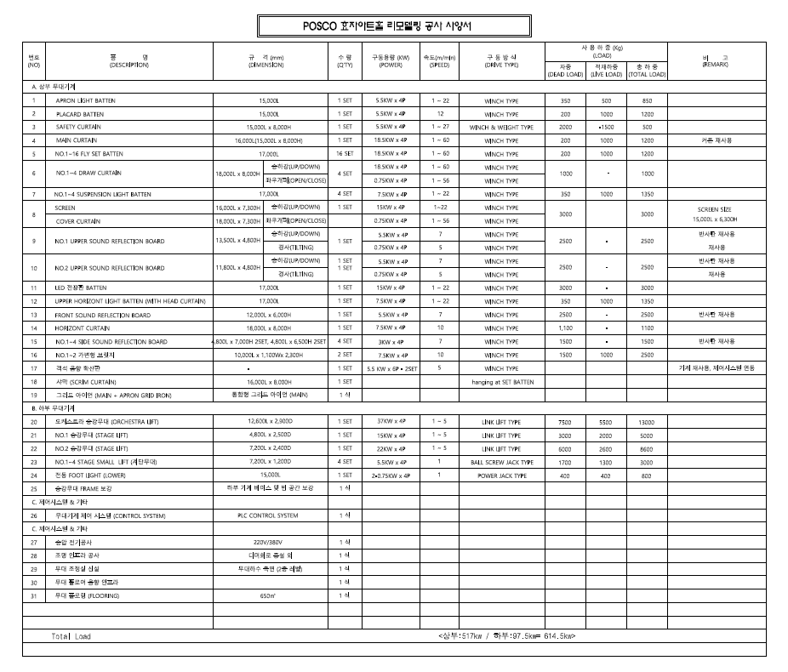
효자아트홀 무대기계 설비 현황

효자아트홀 무대음향 설비 현황
순번 | 품 명 | 규 격 / 사 양 | 수량
1 | MAIN SPEAKER | L-ACOUSTICS/KARA | 16
2 | MAIN SUB SPEAKER | L-ACOUSTICS/ SB-18 | 4
3 | SUBWOOFER SPEAKER | D&B B22 | 2
4 | STAGE MONITOR SPEAKER | D&B M4 | 8
5 | MONITOR SPEAKER | L-ACOUSTICS/ SYVA | 2
6 | POWER AMP | L-ACOUSTICS/ LA12X | 5
7 | POWER AMP | L-ACOUSTICS/ LA4X | 2
8 | POWER AMP | D&B D30 | 3
9 | CONTROL ROOM SPEAKER | GENELEC. 1031A | 2
10 | HOUSE AUDIO MIXER | MIDAS_PRO-X | 1
11 | HOUSE AUDIO MIXER | MIDAS_HERITAGE-D | 1
12 | CD PLAYER | DENON. DN-D4000 | 2
13 | HEADPHONE | SONY-7506 | 1
14 | WIRELESS MIC SYSTEM | UR4/D | 18
15 | SUSPENSION MIC | MKH8060 | 4
16 | AIR MONITOR MICROPHONE | CROWN. PZM-20R | 2
17 | MICROPHONE #1 | SHURE. SM58 | 20
18 | MICROPHONE #2 | SHURE. SM57 | 10
19 | MICROPHONE #3 | SHURE. BETA58A | 10
20 | MICROPHONE #4 | SHURE. BETA57A | 10
21 | MICROPHONE #5 | SHURE. BETA52 | 5
22 | MICROPHONE #6 | Shure Beta98 H/C | 5
23 | CONDENSOR MICROPHONE #1 | AKG. C400BL | 4
24 | CONDENSOR MICROPHONE #2 | AKG. C535EB | 5
25 | DRUM MIC SET | AKG. w/ D112 x1EA & C418 x 4EA | 1
효자아트홀 무대조명 설비 현황
순번 | 품 명 | 규 격 / 용 량 |  | 수량
1 | Light Control Console | Grand-MA | MA1 Full-Size | 1SET
2 | Dimmer | 5Kw | EURODIM2 T-T | 288
3 | Zoom Profile 2kw Spot Light | 220v/2Kw | DN-205 8"10◦~22◦ | 24
4 | Zoom Profile 2kw Spot Light | 220v/2Kw | DS-201 8"18◦~22◦ | 18
5 | Source Four Spot Light | 220V/750w | 6" 15◦~ 36◦ | 36
6 | Source Four Spot Light | 220V/750w | 6" 15◦~50◦ | 12
7 | Zoom Profile 1Kw Spot Light | 220V/1Kw | DS-101 6" 18◦~22◦ | 29
8 | Zoom Profile 1Kw Spot Light | 220/1Kw | DW104 6" 15◦~42◦ | 2
9 | Zoom Profile 1Kw Spot Light | 220V/1Kw | DS104 6" 15◦~31◦ | 3
10 | Plano Convex Spot Light | 220V/1.2Kw | C-101 6" 10◦~65◦ | 48
11 | Fresnel Spot Light | 220V/1.2Kw | F-101 6" 13◦~59◦ | 40
12 | Lower LED-BAR | 220V/270w | LWB-6 18구15w | 12
13 | Upper LED-BAR | 220V/270w | LWB-6 18구15w | 14
14 | Par Light R-46 | 28V/250w | 250w | 48
15 | Par Light R-64 | 220V/1Kw | 1Kw | 10
16 | Follow pin spot Light | 220V/1.2Kw | Xenon 1.2Kw | 2
17 | Bank Light | 220V/250w | 4구 | 12
18 | Fog Machine | 220V/1.5Kw | ZR33 | 2
19 | Fog Machine | 220V/920w | Magnum 2500Hz | 1
20 | Dry Ice Machine | 220V6Kw | Aquafog 3300 | 2
21 | Buble Machine | 220V/0.5A | Master 2000 | 2
22 | Strobe | 220v/3Kw | Atomic 3000 DMX | 2
23 | Diablo | 220V400W |  | 4
24 | Snow Machine | 220v/600w | Antari S-200 | 2
25 | Moving Light (profile) | 220V/700W | MAC 700 P | 12
26 | Moving Light (Wash) | 220V/700W | MAC 700 W | 12
27 | Moving Light (Effect) | 220V/1.2Kw | MAC 2000 Performance | 1
28 | LED Moving Wash Light | 220V/600W | Robe Spider | 8
효자아트홀 영사 설비 현황
순번 | 품 명 | 규 격 / 사 양 | 수량
1 | 디지털 시네마
1 | Digital Cinema System | 4K Cinema Laser Projector | 1
1 | Server | Dolby Cinema Server | 1
1 | Cinema Sound Processer | CP-750 | 1
1 | Control PC |  | 1
1 | RGB 줌렌즈 | CP4325 | 1
2 | 스피커 시스템
2 | Main L,C,R Speaker System | SC-443C | 3
2 | Sub Woofer Speaker System | SB-7218 | 4
2 | Surround Spraker System | SR-1030 | 30
2 | Surround Spraker Brackert |  | 30
2 | Main & Woofer Speaker 전용카트 |  | 1
2 | Power Distributor | NS-8S | 1
3 | 앰프 시스템
3 | Main L,C,R Speaker AMP(High용) | DCA-1622 | 3
3 | Main L,C,R Speaker AMP(Low용) | DCA-3422 | 3
3 | Sub Woofer Speaker Amp | DCA-2422 | 4
3 | Surround Spraker AMP | DCA-1622 | 4
4 | 공연/행사용 Projector
4 | 3Chip DLP Projector | WU-20K-J(음향실내 사용) | 1

